## Create a directory and manage files

# Create a directory named test_dir

mkdir test_dir

# Navigate into the directory

cd test_dir

# Create an empty file called example.txt

touch example.txt

# Rename example.txt to renamed_example.txt

mv example.txt renamed_example.txt

## Display /etc/passwd contents

* # Display the contents of /etc/passwd

cat /etc/passwd

# Display only the first 5 lines of /etc/passwd

head -n 5 /etc/passwd

# Display only the last 5 lines of /etc/passwd

tail -n 5 /etc/passwd

## Find lines containing 'root'

grep "root" /etc/passwd

## Compress and decompress a directory

cd ..

zip -r test_dir.zip test_dir

mkdir unzipped_dir

unzip test_dir.zip -d unzipped_dir

## Download a file using wget

example.com/sample.txt](https://example.com/sample.txt)

## Create a file and set read-only permissions

touch secure.txt

chmod 444 secure.txt

ls -l secure.txt

-r--r--r-- 1 user group 0 May 30 12:00 secure.txt

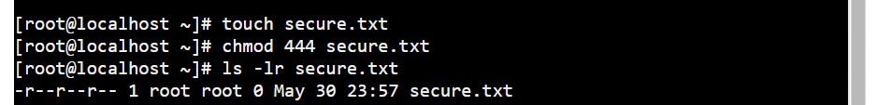

## Set an environment variable

export MY_VAR="Hello, Linux!"

echo $MY_VAR

